Smart Bulbs

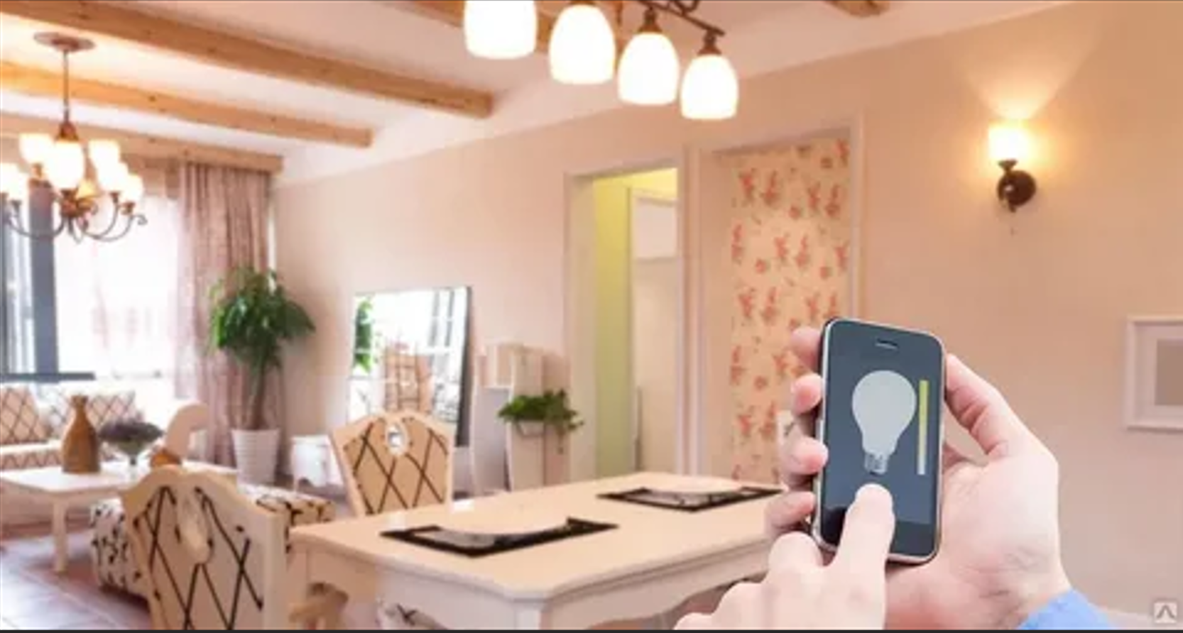

**Description:**

**Smart Bulbs** are advanced, energy-efficient lighting solutions that allow you to control your lights remotely using a smartphone app or voice commands. These bulbs are perfect for creating the perfect ambiance for any occasion, from cozy movie nights to vibrant parties. With features like dimming, color changing, and scheduling, Smart Bulbs offer a convenient and customizable lighting experience.

* **Technology:** Wi-Fi, Bluetooth, or Zigbee (depending on the model).
* **Compatibility:** Works with iOS and Android devices.
* **Bulb Type:** A19 (standard bulb shape), E26 base.
* **Wattage:** 9W (equivalent to 60W incandescent).
* **Lumens:** 800 lumens.
* **Color Options:** 16 million colors + adjustable white light (2200K-6500K).
* **Dimmable:** Yes.
* **Lifespan:** 25,000 hours.
* **Energy Efficiency:** Energy Star certified.
* **Control Options:** Mobile app, voice control (Alexa, Google Assistant, Apple HomeKit).

**Key Features:**

* **Customizable Lighting:** Choose from 16 million colors and adjust brightness to create the perfect ambiance.
* **Voice Control:** Compatible with Alexa, Google Assistant, and Apple HomeKit for hands-free control.
* **Energy-Efficient:** Uses up to 85% less energy than traditional incandescent bulbs.
* **Scheduling and Automation:** Set schedules, timers, and routines for automated lighting control.
* **Group Control:** Control multiple bulbs simultaneously for synchronized lighting.
* **Music Sync:** Some models offer music sync features that change colors with the beat of your music.

**Pricing:**

* **Single Bulb:** $24.99
* **2-Pack:** 44.99(44.99(22.50 per bulb)
* **4-Pack:** 79.99(79.99(20.00 per bulb)

**Where to Use:**

* **Living Rooms:** Create a cozy or vibrant atmosphere with customizable colors.
* **Bedrooms:** Set the perfect lighting for relaxation or wake-up routines.
* **Kitchens:** Brighten up workspaces with adjustable white light.
* **Home Offices:** Enhance productivity with focused lighting.
* **Parties:** Set the mood with dynamic color-changing effects.

**Customer Reviews:**

* ⭐⭐⭐⭐⭐ "These Smart Bulbs are amazing! They were super easy to set up, and I love controlling them with my phone. The colors are so vibrant!" – Sarah L.
* ⭐⭐⭐⭐ "Great value for the price. The bulbs are bright, and the app is easy to use. Highly recommend for anyone looking to upgrade their smart home lighting." – James T.
* ⭐⭐⭐⭐⭐ "I love how energy-efficient these bulbs are. The scheduling feature is a game-changer for my daily routine." – Emily R.

**How to Order:**

1. Visit our website: [www.brightworldlighting.com](http://www.brightworldlighting.com/)
2. Select your preferred pack size (Single, 2-Pack, or 4-Pack).
3. Add to cart and proceed to checkout.
4. Enjoy free shipping on all orders over $50!

**Warranty and Support:**

* **Warranty:** 2-year limited warranty covering manufacturing defects.
* **Customer Support:** Contact us at [support@brightworldlighting.com](mailto:support@brightworldlighting.com) or call +1-800-123-4567 for assistance.

**Visual Representation:**

Include high-quality images of the Smart Bulbs in different settings (e.g., living room, bedroom) to showcase their versatility and design.